FAST DRY ZINC PHOSPHATE PRIMER
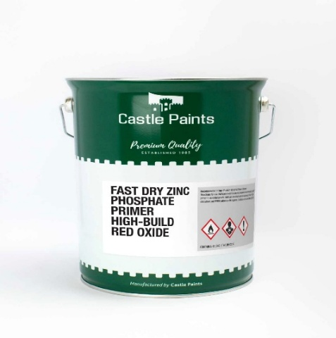

COLOUR | Size | Size | Size | Size
Red | 1.0lt | 2.5lt | 5.0lt | 20lt
Grey | 1.0lt | 2.5lt | 5.0lt | 20lt
Black |  |  | 5.0lt | 20lt

Product Description:
Fast Dry Zinc Phosphate Primer High Build is a high build, fast drying alkyd primer pigmented with zinc phosphate and inert fillers. The dry film is tough, hard and has moderate chemical resistance, with excellent adhesion. It does not contain lead
Intended Use:
It is particularly suitable as an anti-corrosive primer for steel fabrications, Industrial & Agricultural machinery etc, where fast drying and high build properties are required. When used in conjunction with Castle G30, G60 or G90 Topcoats, Fast Dry Zinc Phosphate High Build Primer is recommended for exterior use on structural steel, Agri & Industrial machinery, and all steelwork where a level of protection conforming to ISO 12944 C1 – C3 is required. This primer is also recommended for use in intumescent paint systems

Application Details:

Application Method: Brush or spray
Thinner: Premium Thinners (Xylene)

OXIDE GLOSS ENAMEL

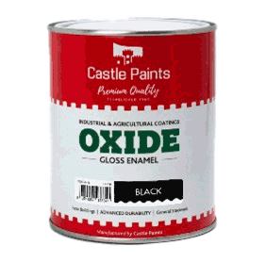

COLOUR | Size | Size | Size
Red | 2.5lt | 5.0lt | 20lt
Grey | 2.5lt | 5.0lt | 20lt
Black | 2.5lt | 5.0lt | 20lt
Juniper Green |  | 5.0lt | 20lt

Product Description:
Oxide Gloss Enamel is an oil alkyd based synthetic paint giving a good coverage, high gloss, durable, anti-corrosive finish. It is ideal for industrial and agricultural use. All colours are lead free and VOC compliant.
Intended Use:
Oxide Gloss Enamel is suitable for weathered galvanised farm buildings and general steelwork. It can also be used on suitably prepared and primed wood.
Application:
The normal recommendation is to apply one coat of Castle Paints W/S Metal Primer followed by one coat of Castle Paints Oxide. For improved finish on rough or textured surfaces one coat of Castle Paints W/S Metal Primer followed by two coats of Castle Paints Oxide is recommended. Fresh galvanised corrugated iron should be allowed to weather or first coated with a T-wash solution or Etch Primer. Apply only in warm, dry weather. Do not apply late in the day if there is a risk of fog or mist. When using more than one can of paint check the batch numbers are identical and if not intermix before use
Application Details:
Application Method: Brush, roller or spray
Thinner: Low odour white spirit

FAST DRY MACHINERY ENAMEL
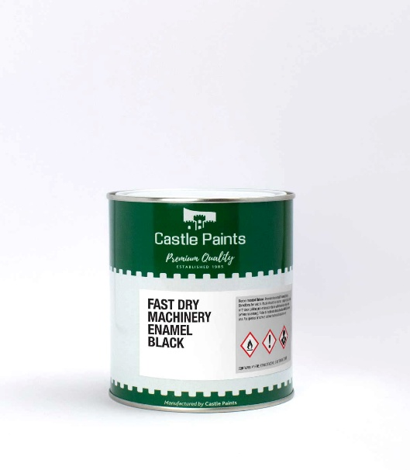
COLOUR | Size | Size | Size | Size
Black | 1.0lt | 2.5lt | 5.0lt
White |  |  | 5.0lt
John Deere Green |  |  | 5.0lt
JCB Yellow |  |  | 5.0lt | 20lt
Massey Fergusen Red |  |  | 5.0lt
Ford Tractor Blue |  |  | 5.0lt
Industrial Blue |  |  | 5.0lt

Product Description:

G90 Fast Dry Machinery Enamel is an alkyd-based finish coat that provides a tough gloss finish and is resistant to oil.

Intended Use:

G90 Fast Dry Machinery Enamel is generally used as a topcoat in single pack alkyd paint systems. It is recommended for various types of machinery and equipment, and as a topcoat on steel structures.

Application Details:

Application Method: Brush or spray
Thinner: Premium Thinners (Xylene)

FAST DRY GLOSS

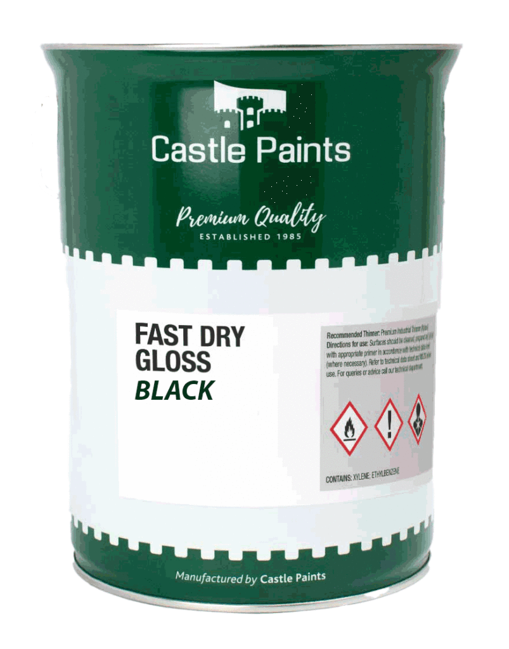
COLOUR | Size | Size
Red | 5lt | 20lt
Grey | 5lt | 20lt
Green |  | 20lt

Product Description:

G90 Fast Dry Machinery Enamel is an alkyd-based finish coat that provides a tough gloss finish and is resistant to oil.

Intended Use:

G90 Fast Dry Machinery Enamel is generally used as a topcoat in single pack alkyd paint systems. It is recommended for various types of machinery and equipment, and as a topcoat on steel structures.

Application Details:

Application Method: Brush or spray
Thinner: Premium Thinners (Xylene)

HIGH BUILD VINYLS
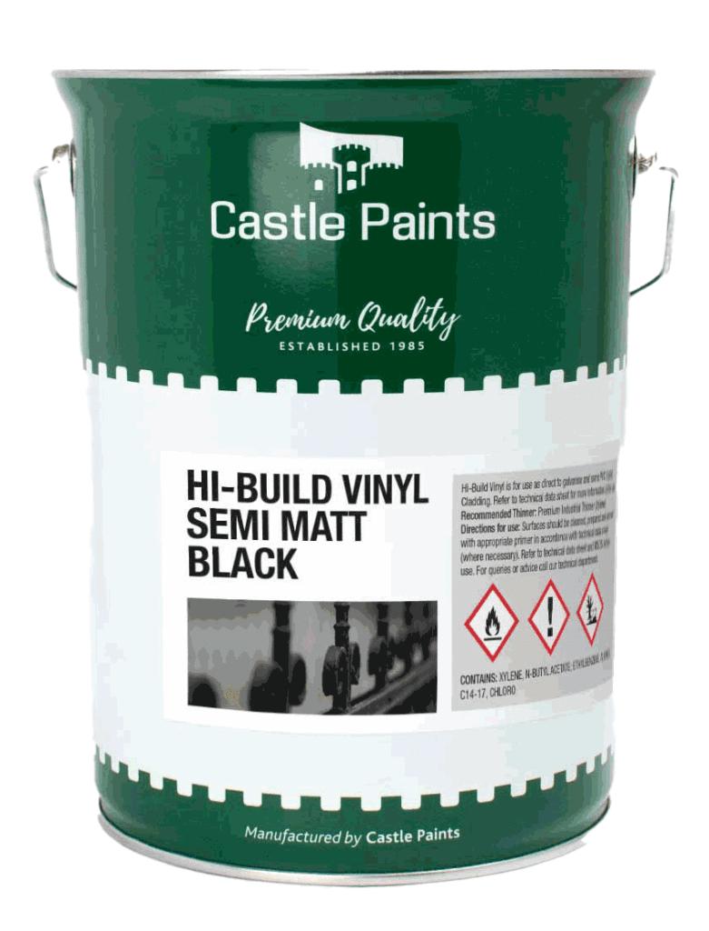

COLOUR | Size | Size
White |  | 5.0lt
Black | 2.5lt | 5.0lt
Moss Green |  | 5.0lt
Aluminum |  | 5.0lt

Product Description:

High Build Vinyl – Semi-Matt is a fast drying, high performance, anti-corrosive, self-priming semi-matt finish for use on:
- Metal gates, railings and fences. Adheres directly to galvanised metal or steel.
- Steel structures subject to low temperatures or high humidity.
- Cladding Paint (test area and technical assistance required before use).
- General metal fabrication where superior adhesion & durability is required.
- As an alternative to Pliolite as a high-performance external wall coating.

Intended Use:

A fast drying, low sheen primer/topcoat giving a tough flexible coating with outstanding adhesion to many difficult areas. Not suitable for use in areas subject to chemical/solvent attack.

Application:
Apply 2 coats min 75 microns dft.
Application Method: Brush or spray
Thinner: Premium Industrial Thinner (Xylene)

THINNERS
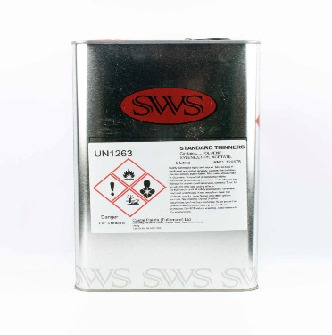

PRODUCT | Size | Size
Standard Thinners | 5.0lt | 20lt

Product Description:

Standard Thinners can be used for Cleaning & washing with industrial paints.

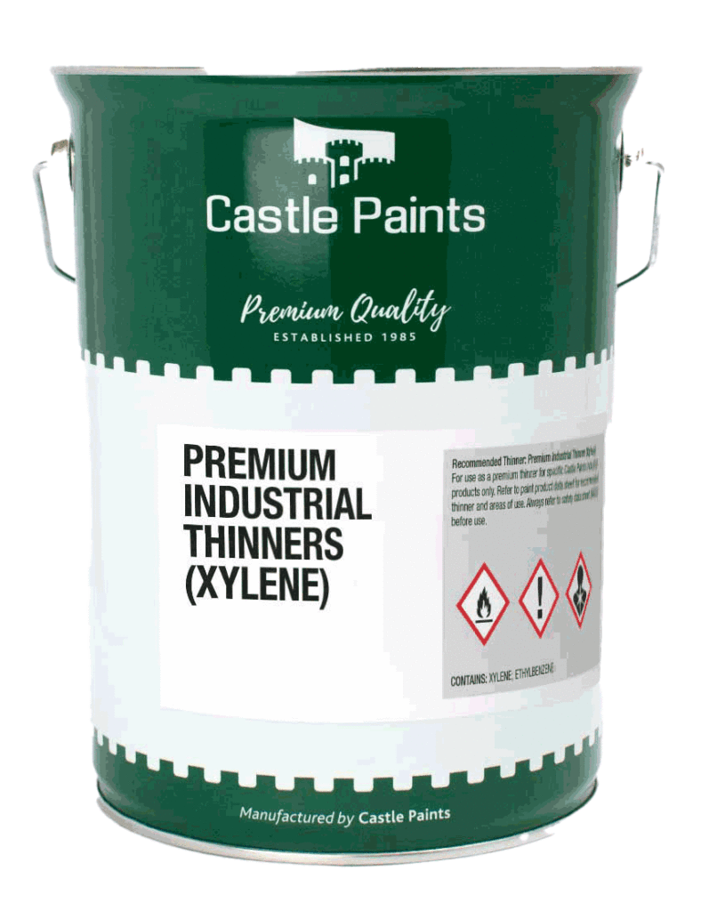
PRODUCT | Size | Size | Size
Xylene Thinners | 1.0lt | 5.0lt | 20lt

Product Description
A very high-quality premium industrial thinner for use with Fast Dry Gloss, Machinery Enamel, Chlorinated Rubber, etc

ZINGA PAINT & ACCESSORIES
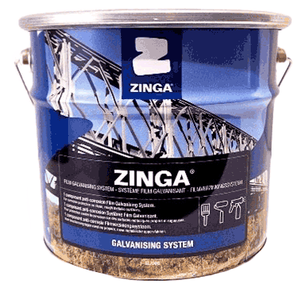

PRODUCT | Size | Size | Size | Size | Size | Size
Zinga | 500ml | 1.0lt | 2.0lt | 5.0lt | 10.0lt | 25lt

Product Description
ZINGA is a unique film galvanising coating that provides active cathodic protection and passive barrier protection to steel substrates. It is often described as cold galvanising — but, unlike conventional paints, it is an active zinc corrosion protection system

Key Facts
- Composed of a high zinc content (~96% dry film zinc).
- Combines active (galvanic) and passive (barrier) protection mechanisms.
- Provides corrosion resistance comparable to hot-dip galvanising, yet can be applied in many conditions.

Application & Practical Use
- Can be applied on site or in workshop by brush, roller, or spray.
- Works in wide temperature ranges and weather conditions.
- Suitable for both new steel and repair of worn galvanized or thermally sprayed surfaces.

Performance Attributes
- Quick drying (touch dry in ~10 minutes at 20 °C).
- Flexible and forgiving — does not crack or become brittle.
- Unlimited shelf life and pot life — no wasted material or time.
- Non-toxic: can be in contact with potable water.

ZINGA PAINT & ACCESSORIES
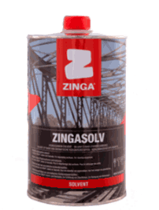

PRODUCT | Size | Size
Zingasolv Thinner | 1.0ltr | 5.0ltr

Product Description
Zingasolv is a C9-C10 aromatic hydrocarbon solvent. Zingasolv is manufactured to the highest standards. It does not contain detectable quantities of polycyclic aromatics, heavy metals or chlorinated compounds.

ZINGA PAINT & ACCESSORIES
Zinga Spray
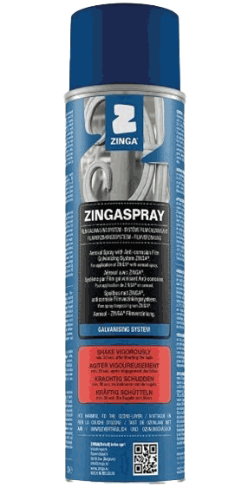

Product description: Zinga Spray

Zingaspray offers the film galvanising system ZINGA in an aerosol spray for easy small applications.
ZINGA contains 96% Zinc in the dry film and provides cathodic protection to ferrous metals.
Zingaspray is ideal for the repairing and touching-up of damaged or old hot-dipped, Zinganised or other zinc coated structures. It’s Zinc Grey in Colour

Characteristics:
- Colour is Zinc Grey
- Good resistance to mechanical shocks, abrasion and erosion
- Very economical - Efficient and solid, ideal for spot welding
Zingalu Spray
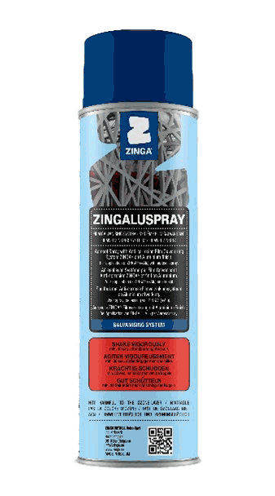

Product description: Zingalu Spray

Zingaluspray offers the film galvanising system ZINGA in an aerosol spray for easy small applications.To match a Hot Dip Galvanised surface; Aluminium flakes have been added. Zingaluspray still contains 92% Zinc in the dry film and provides cathodic protection to ferrous metals. Zingaluspray is ideal for the repairing and touching up of damaged or old hot-dipped, Zinganised or other zinc coated structures.

Characteristics:
- Colour is Zinc Grey
- Good resistance to mechanical shocks, abrasion and erosion
- Very economical - Efficient and solid, ideal for spot welding

AEROSOL SPRAYS

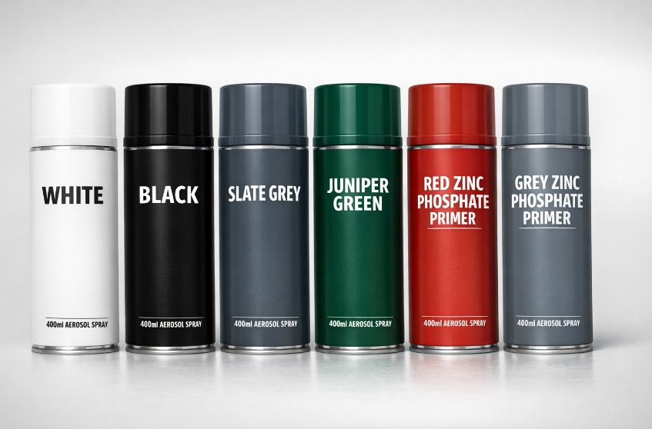

Fast Dry Gloss
PRODUCT | Size
White Fast Dry Gloss | 400ml
Black Fast Dry Gloss | 400ml
Slate Grey Fast Dry Gloss | 400ml
Juniper Green Fast Dry Gloss | 400ml

Zinc Phosphate Primers
PRODUCT | Size
Red Zinc Phosphate Primer | 400ml
Grey Zinc Phosphate Primer | 400ml

Line Marking Sprays
PRODUCT | Size
White Line Marking Spray | 750ml
Yellow Line Marking Spray | 750ml

BRUSHES AND ROLLERS

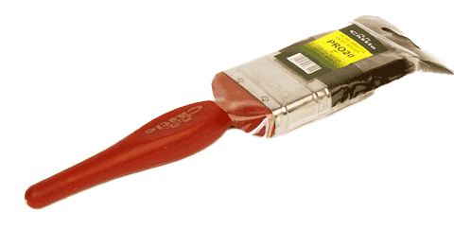
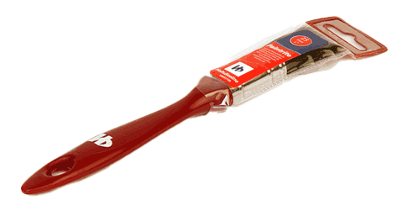

25mm Paint Brush 50mm Paint Brush

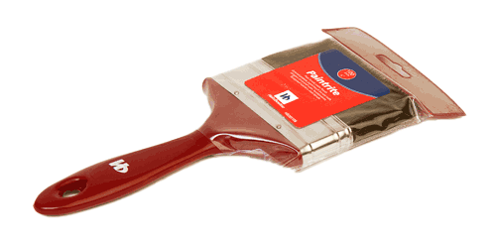
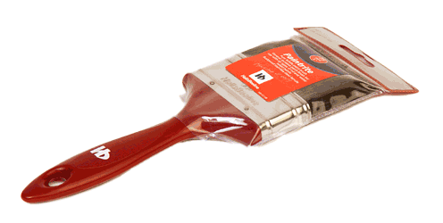

75mm Paint Brush 100mm Paint Brush

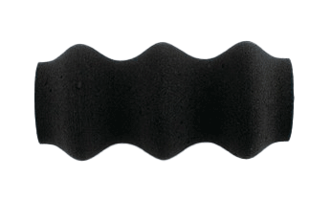
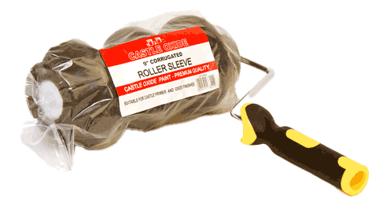

9” Corrigated Roller 9” Corrigated Roller Sleeve

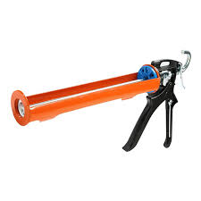

Heavy Duty Mastic Gun

ADHESIVES & MASTICS

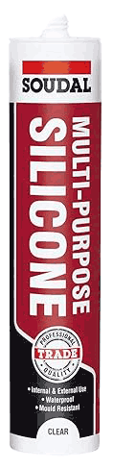
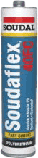

Soudaflex 40FC Mastic Soudal Trade Silicone Clear
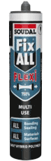

Soudal Trade Silicone Black Soudal Fix All Black

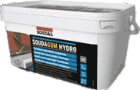
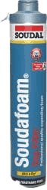

Soudafoam Expanding Foam Soudal SoudaGum Hydro

