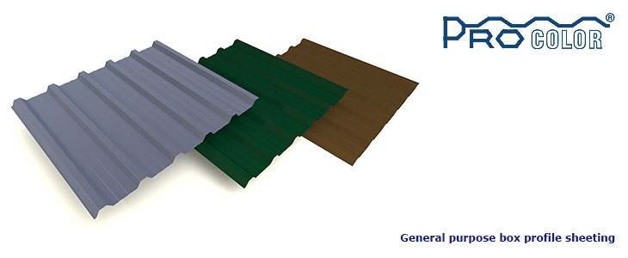

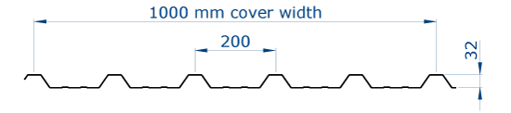
Thickness (mm) | 0.5 | 0.6
Colour | Slate Grey  Juniper Green  Black | Slate Grey  Juniper Green  Black  Oxide Red

Corricolor is our general-purpose corrugated sheeting. It is used in Roof and Wall applications where the environmental conditions do not pose a significant corrosion risk to metal sheeting.

Stock Lengths available to collect in our yard: in Juniper Green & Slate Grey in 0.50mm.
Juniper Green | Juniper Green | Slate Grey | Slate Grey
1.829mt (6’0”) | 3.353mt (11’0”) | 1.829mt (6’0”) | 3.353mt (11’0”)
2.143mt (7’0”) | 3.657mt (12’0”) | 2.143mt (7’0”) | 3.657mt (12’0”)
2.438mt (8’0”) | 4.267mt (14’0”) | 2.438mt (8’0”) | 4.267mt (14’0”)
2.743mt (9’0”) | 4.880mt (16’0”) | 2.743mt (9’0”) | 4.880mt (16’0”)
3.048mt (10’0”) |  | 3.048mt (10’0”)

Custom cut lengths are available upon request, enquire with sales.

DPC Barrier
To prevent corrosion caused by contact with wet, green or treated timber a DPC barrier must be used when Procolor is fixed to timber purlins.

